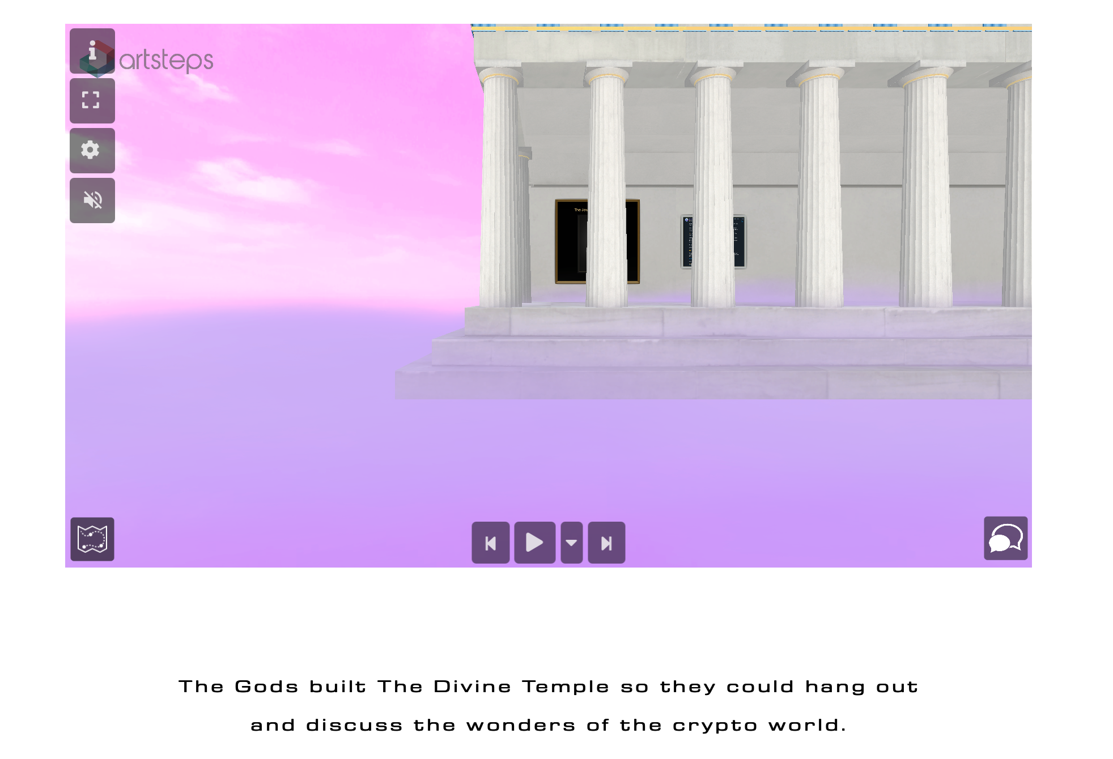
The Divine Temple
Anybody and visit and walk around the virtual space. You must accept all cookies.

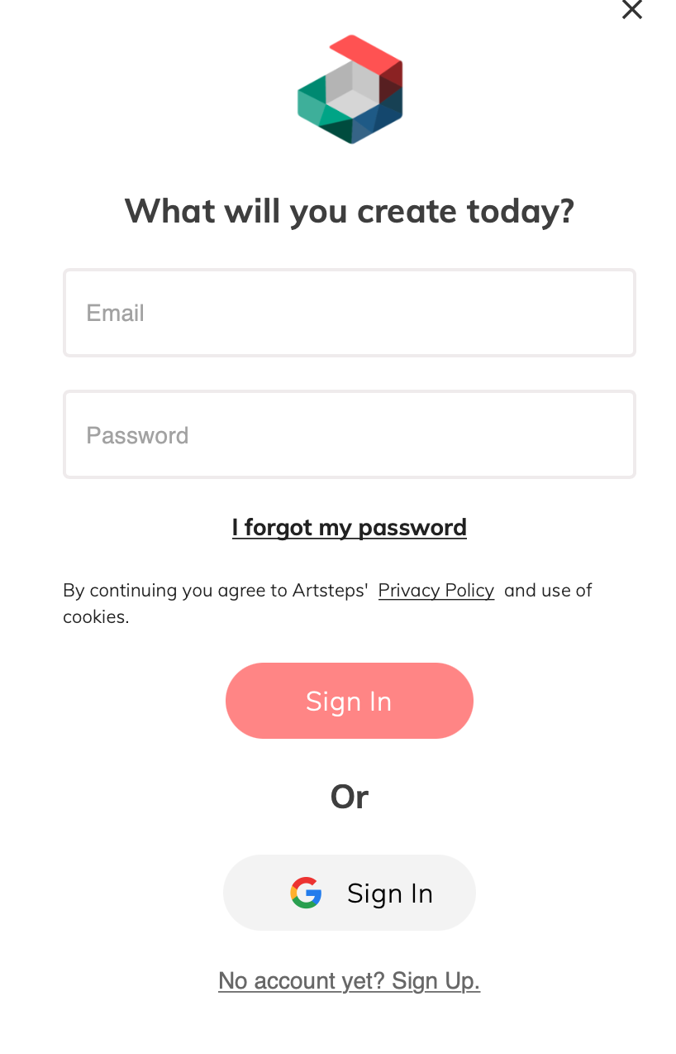

But if you want a little avatar and to use chat box you must log in. You can not log in on the cryptogods website. To log in you can click the artistes logo in the top left corner or go to artsteps.com and log in.
You can log in with gmail quick and easy or create an account.

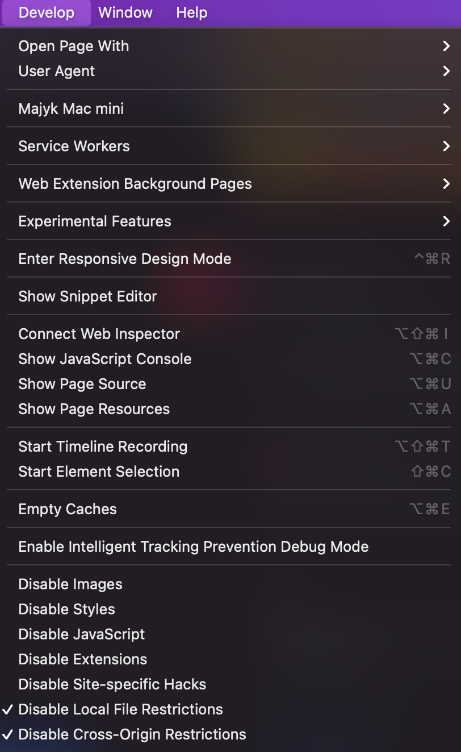
Once you are logged in you can either find The Divine Temple in the artsteps search on their website or you can go back to cryptogods.io page (in the same browser) and refresh the page and it will be logged in also on the crypto gods website.
If the chat box isn’t working after log in then you need to disable ad blocker (especially on Brave browser). On Safari browser you may need to go to the top safari menu and click ‘developer’ then click the two disable restrictions options seen in the image to the right.

The experience for this mini meta verse space is much better on a desktop browser. You click settings to change the quality depending on the power of your computer too. If you want to use a mobile it may not work but if it does you should make it full screen and choose low quality.

There is an audio button you can turn on and off. There is all the option to press play and follow the automatic map or you can walk freely using the mouse to click and where you want to go. You can look around with the mouse and you can use keyboard arrow keys to zoom in and out too.
Some of the wall media is interactive. This space can host images, gifs, videos, 3D objects and audio.

Have a blessed visit!

